Transparency Master

Ecological Habitat Diagrams

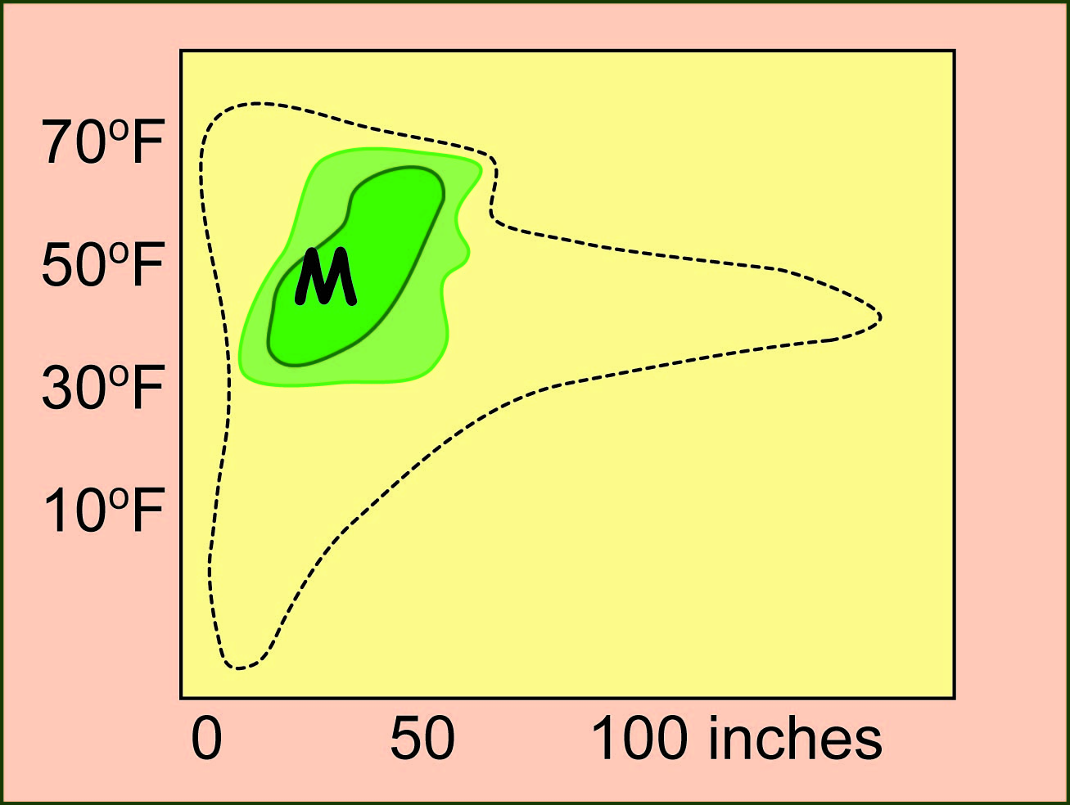

M = Michigan

Transparency Master

Matching Tree Species with Ecological Habitat Diagrams

Predicting the Future Ranges of Important Tree Species
Sugar Maple

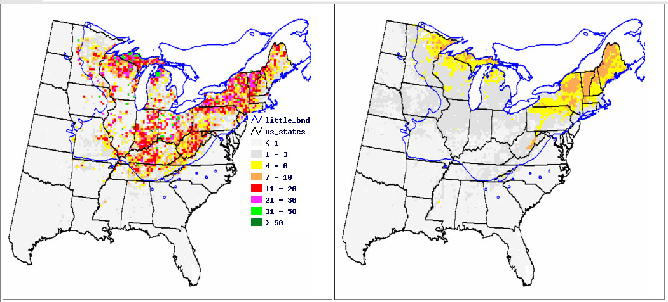
Present Range
Predicted Range 2100

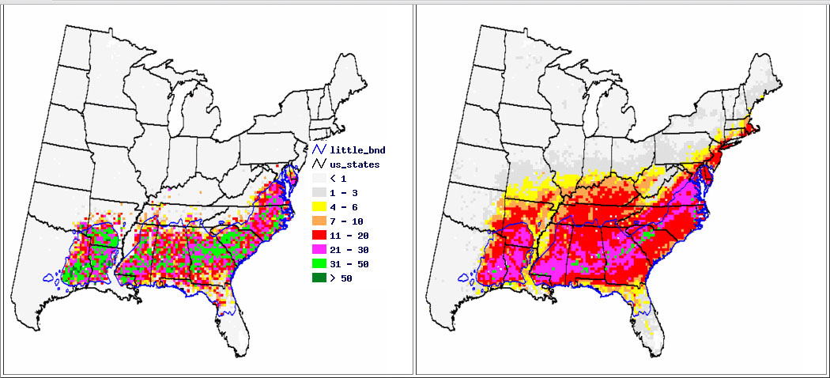
Loblolly Pine
Present Range
Predicted Range 2100
Predicting the Future Ranges of Important Tree Species
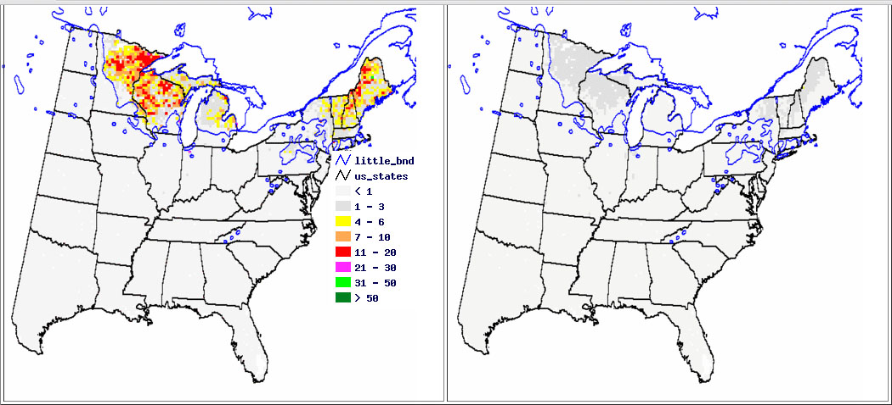
Predicting the Future Ranges of Important Tree Species
Predicted Range 2100
Present Range
Predicted Range 2100
Present Range
Paper Birch

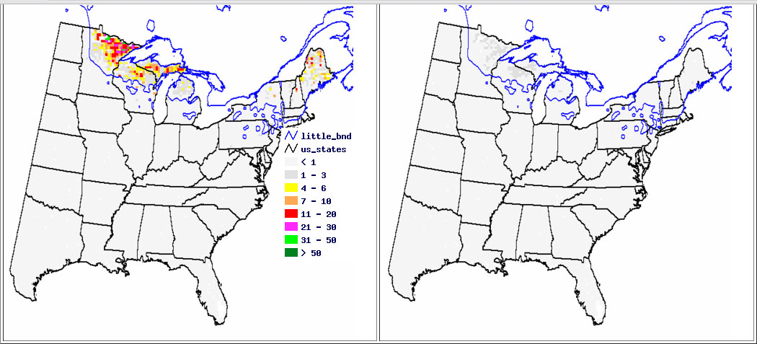
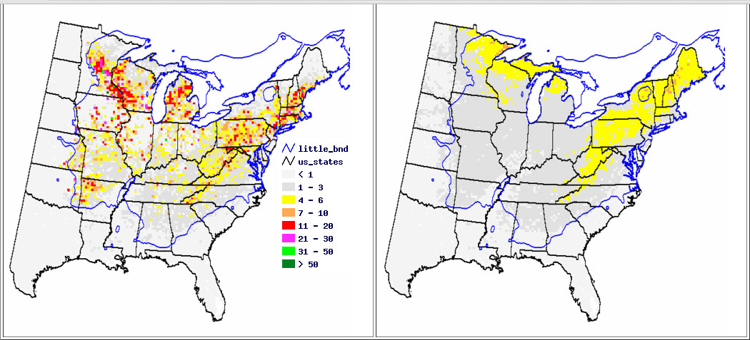
Present Range
Predicted Range
Black Spruce
Predicted Range
Red Oak
Present Range
Predicting the Future Ranges of Important Tree Species
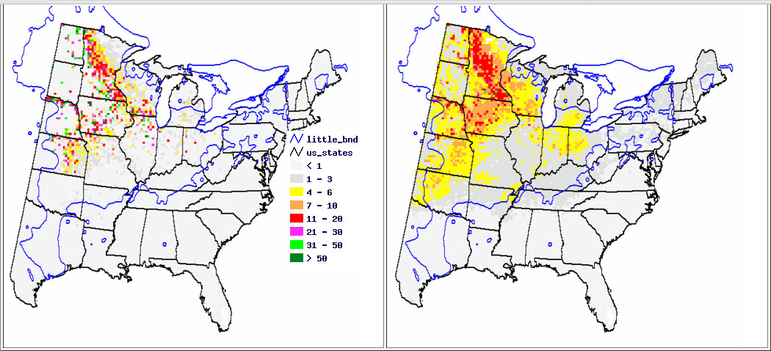
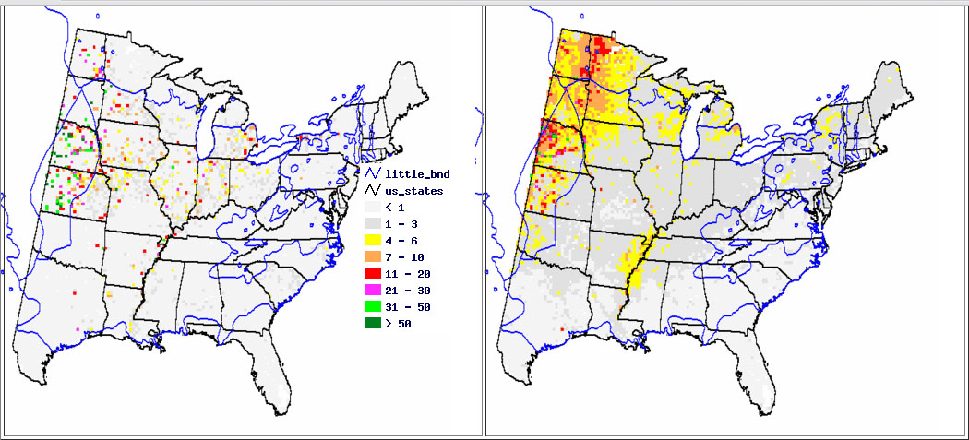
Bur Oak
Predicted Range 2100
Present Range
Cottonwood
Present Range
Predicted Range

